**Git & GitHub**

* Git is Distributed Version Control System (DVCS).
* Distributed means it allows all the collaborators to have copy of the repository they are working upon on their local machine.

GitHub

Git

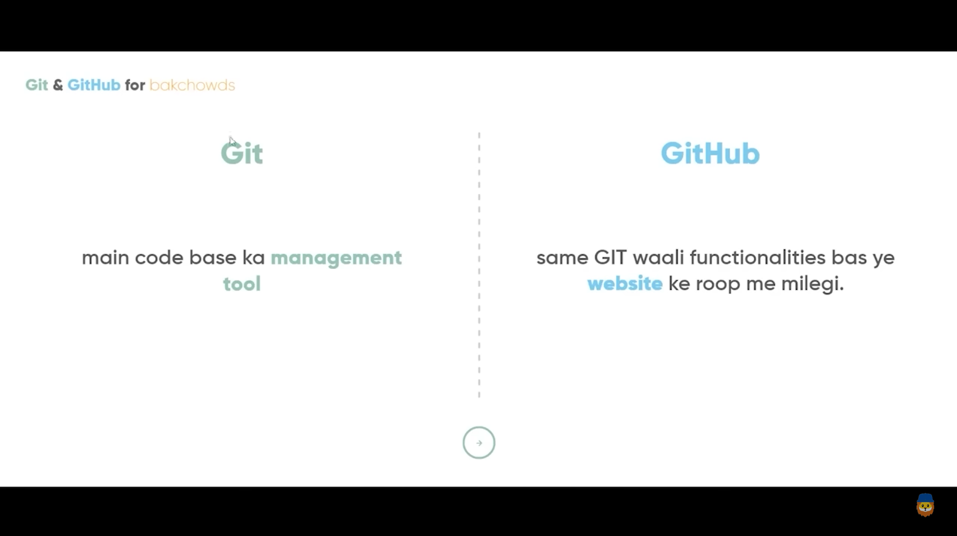

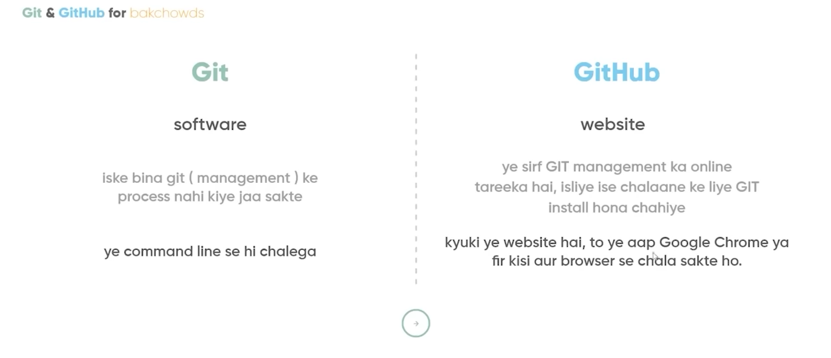

* Git Areas :-

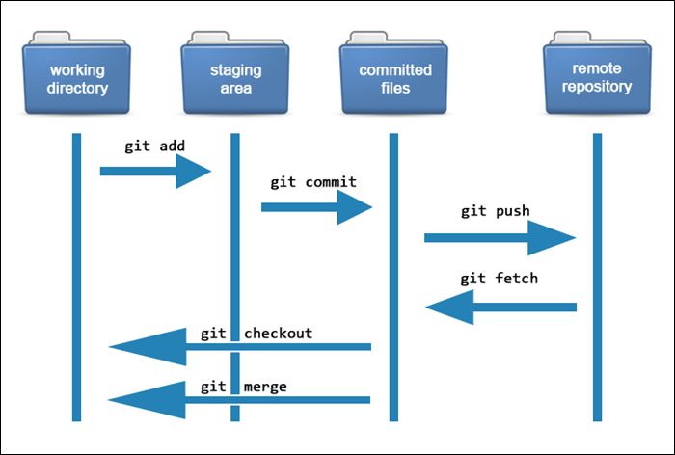

1. Working – space : where u make changes to the files.
2. Staging area (git add) : files that are staged i.e., ready to be commited. If you make changes to 10 files, but only 5 files are related to your work, you can add those 5 files only to the staging area.
3. Local repo/commited files (git commit -m “ ”) : contains commited files with some commitment message. Files in this section will be pushed to remote repo. Git commit ensures that your changes are properly saved, documented, and versioned within your local repository.

( saved changes = commit )

* Git process :-
* git init
* git add .
* git commit -m “ comment ”
* git remote add origin Remote_Repository_URL
* git pull origin main
* git push -u origin main

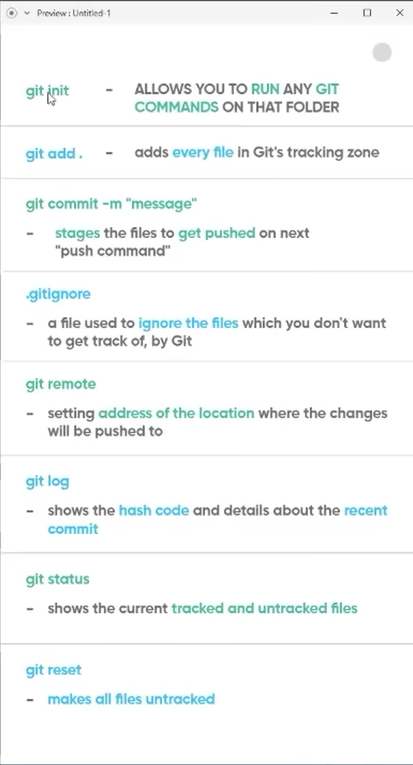

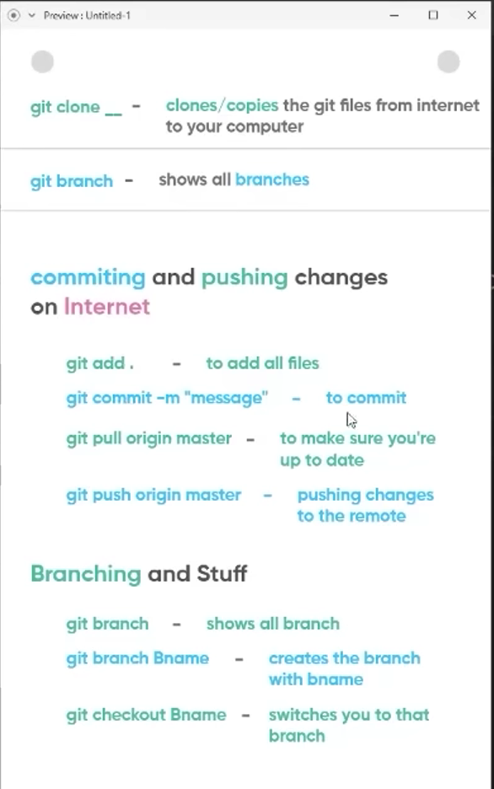



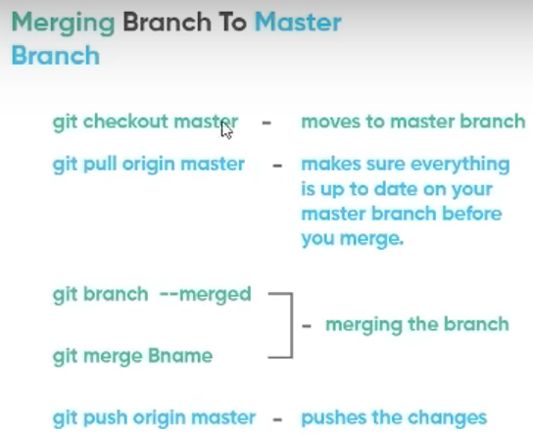

* To unstage the file : git rm --cached [filename]
* Branching : branching is a feature in git that allows developers to work upon the copy of the actual code to fix bugs or develop new features.
* By working on a branch devs don’t affect the master branch, until they want to implement the changes.
* The master branch generally represents the stable version of your code.

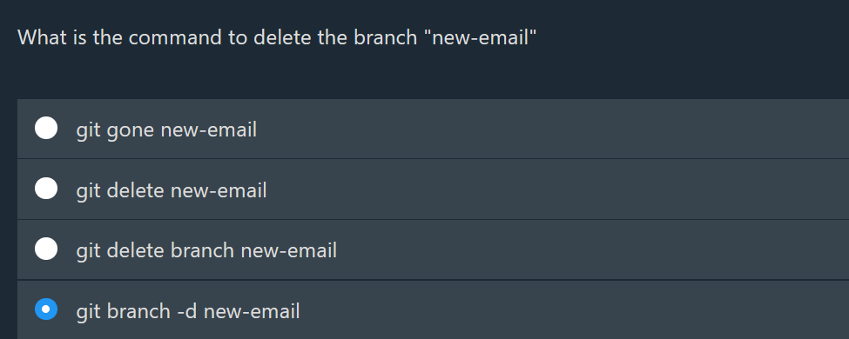

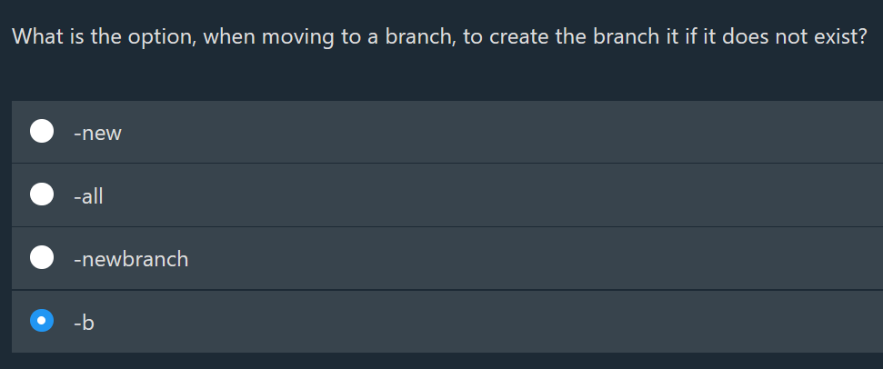

* log :
* To avoid long description of the commits, use --oneline with log.
* i.e., git log –oneline
* it will return a list like this :

